PROJECT NAME:MARKET BASKET INSIGHTS

SUBMITTED BY: STEPHEN M

MAIL ID: **manistephen78@gmail.com**

**ABSTRACT:**

In the dynamic landscape of retail, understanding consumer behavior is paramount for businesses seeking to optimize sales strategies and enhance customer experiences. This abstract introduces a comprehensive study focused on market basket insights—a data-driven approach to unraveling the intricate web of consumer purchasing patterns.

Our research delves into the core concepts of market basket analysis, utilizing advanced data mining techniques to extract meaningful associations and trends from transactional data. By examining the contents of shoppers’ baskets and identifying frequently co-purchased items, we uncover valuable insights that empower retailers to make informed decisions regarding product placement, promotions, and inventory management.

Moreover, this study showcases the practical applications of market basket insights across various industries, from grocery stores to e-commerce platforms. We explore real-world case studies and success stories, highlighting how organizations have leveraged these insights to boost sales, personalize marketing campaigns, and enhance customer satisfaction.

As consumer preferences continue to evolve, the ability to harness market basket insights becomes increasingly essential for businesses to stay competitive and adapt to changing market dynamics. This research serves as a valuable resource for professionals and researchers in the field of retail analytics, offering a glimpse into the power of data-driven strategies in understanding and influencing consumer behavior.

**INTRODUCTION:**

Market basket insights, often hailed as the secret sauce of modern retail, offer a profound glimpse into consumer preferences and behavior. In a world where data reigns supreme, understanding what products customers purchase together can unlock a treasure trove of opportunities for businesses. From enhancing cross-selling strategies to improving inventory management, market basket insights are the compass guiding retailers toward greater profitability and customer satisfaction. This introduction lays the found.

Market basket insights, a cornerstone of modern retail analytics, unveil intricate consumer shopping patterns. In essence, it’s the art of deciphering what items shoppers tend to purchase together during a single shopping trip. This seemingly mundane data can be a goldmine of strategic information for businesses. By understanding these associations, companies can optimize their operations, boost sales, and enhance the overall customer experience.

In today’s hyper-competitive market, where consumers have a plethora of choices, market basket insights are invaluable. They empower retailers to fine-tune their marketing strategies, optimize product placements, and tailor promotions. Moreover, these insights are a potent tool for inventory management, helping businesses minimize wastage and ensure products are in stock when customers want them.

This introduction sets the stage for a deeper exploration of the multifaceted world of market basket insights. From uncovering hidden correlations to shaping personalized recommendations, we’ll journey through the vast landscape of data-driven retail optimization. Join us as we delve into the fascinating realm of market basket insights and discover how they’re reshaping the way businesses understand and cater to consumer needs.

**Problem Definition:**

Market basket insights aim to uncover associations and patterns in customer transaction data to understand the co-occurrence of items in a shopping cart. Specifically, it involves:

**Data Collection:**

Gathering transaction data, typically from point-of-sale systems or e-commerce platforms, including information about items purchased in each transaction.

**Association Rule Mining:**

Applying data mining techniques, such as or FP-Growth, to discover associations or rules that indicate which items tend to be bought together. These rules often consist of antecedents (items in the basket) and consequents (items that also appear).

**Support, Confidence, and Lift:**

Evaluating the strength of these associations using metrics like support (the frequency of occurrence), confidence (the likelihood of the consequent item being purchased given the antecedent), and lift (how much the purchase of the antecedent item affects the purchase of the consequent item).

**Insights Generation:**

Drawing actionable insights from the discovered associations. For example, identifying which items are frequently purchased together can inform marketing strategies, stock placement, or product bundling.

**Business Applications**

: Applying these insights to improve business operations, such as optimizing product placement in physical stores, creating targeted marketing campaigns, or suggesting related products online to increase sales and customer satisfaction.

**OBJECTIVES:**

**Increase Cross-Selling:**

Identify product combinations frequently purchased together to optimize cross-selling and increase average transaction value.

**Inventory Management:**

Improve stock management by recognizing which items are commonly bought together, reducing overstock or out-of-stock situations.

**Promotion Optimization:**

Determine which products should be promoted together to maximize the impact of marketing campaigns and discounts.

**Customer Segmentation:**

Segment customers based on their purchasing patterns to target them with personalized offers and recommendations.

**Store Layout and Design**:

Use insights to optimize store layout, placing related items closer to each other to encourage additional purchases.

**Supply Chain Efficiency:**

Streamline the supply chain by aligning production and distribution with popular product combinations.

**Price Strategy:**

Adjust pricing strategies based on how items are bundled together in customer transactions.

**Loss Prevention:**

Detect and prevent fraud or theft by identifying unusual purchasing patterns.

**Seasonal Trends:**

Understand how customer preferences change with seasons or holidays to plan for inventory and promotions accordingly.

**Customer Experience:**

Enhance the overall shopping experience by tailoring product recommendations and product placements.

**Data Collection:**

Gather transactional data from your sales records, including customer IDs, product IDs, and purchase timestamps.

Store the data securely in a database or data warehouse.

**Data Preprocessing:**

Clean and preprocess the data to handle missing values, outliers, and inconsistencies.

Transform the data into a format suitable for analysis.

**Market Basket Analysis:**

Use association rule mining techniques like or FP-Growth to identify patterns and associations between products frequently bought together.

Calculate metrics like support, confidence, and lift to quantify the significance of these associations.

**Customer Segmentation:**

Cluster customers based on their purchase behavior or demographics.

Identify segments with distinct shopping patterns.

**Visualizations and Reports:**

Create visualizations such as scatter plots, and bar charts to present the insights.

Generate regular reports or dashboard

**Reduce Churn:**

Prevent customer attrition by offering personalized incentives.

**Increase Revenue:**

Maximize revenue by capitalizing on purchasing patterns.

**DESIGN:**

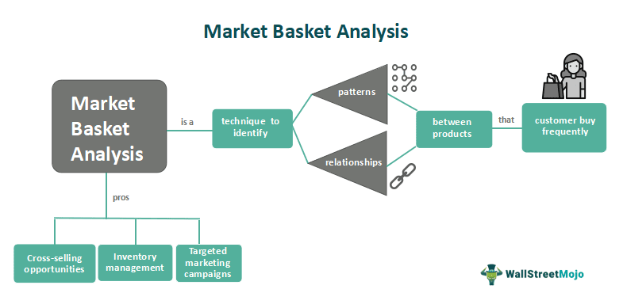

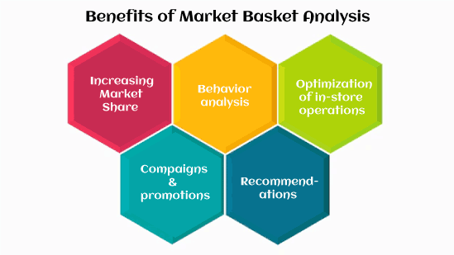

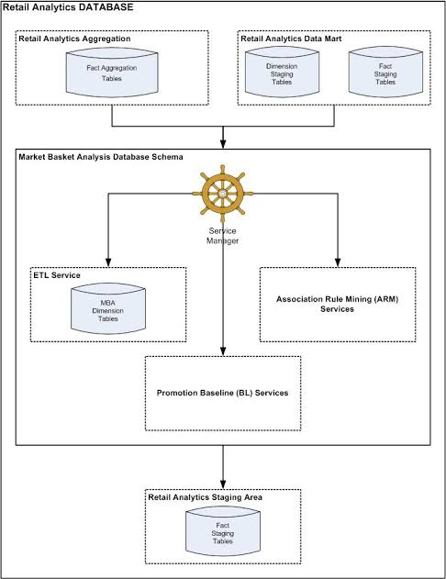

**CONCLUSION:**

Analyzing market basket data has yielded valuable insights into consumer behavior and shopping trends. Through the examination of customer purchase patterns, retailers and businesses can make informed decisions to enhance their marketing strategies and optimize product offerings.

One key observation is the power of product recommendations. By identifying frequently co-purchased items, retailers can create targeted recommendation systems that encourage customers to discover and purchase related products. This not only boosts sales but also enhances the overall shopping experience.

Furthermore, market basket analysis has shed light on seasonality and trends. Retailers can identify which products are popular during specific times of the year and adjust their inventory accordingly. For example, ice cream and sunscreen may see increased sales in the summer, while warm clothing items become more popular in the winter.

Another critical insight is the identification of cross-selling opportunities. Retailers can bundle complementary products together, encouraging customers to buy more than originally intended. For instance, pairing a gaming console with related accessories or offering a discount on a second item can increase average transaction values.

In conclusion, market basket insights are invaluable for retailers and businesses looking to thrive in today’s competitive marketplace. By harnessing the power of data analytics, businesses can enhance their customer experience, optimize inventory, boost sales, and make data-driven decisions that drive growth and success. In an era where data is king, market basket analysis stands as a pillar of informed decision-making for businesses of all sizes.